Week 6 Workshop Tasks

Part 1: Basic SQL Operations and JOIN Queries
- Basic Selection: Retrieve the titles and publication years of all books published after 2000, ordered by publication year (newest first).
select book_id, title, publication_year
from books
where publication_year > 2000
order by publication_year desc;
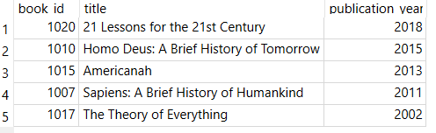

- Filtering: Find all books with more than 5 copies owned in the fiction genre (genre_id = 1).
select title, genre_id, copies_owned
from books
where genre_id=1 and copies_owned > 5;
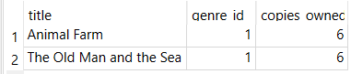

- Pattern Matching: List all books whose titles contain the word "History".
select book_id, title
from books
where title like '%History%';

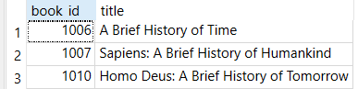
- JOIN Operations: Display loan information (loan_id, checkout_date, due_date) along with patron details (first_name, last_name, email) for all loans made in January 2023.
select Loans.loan_id, Loans.book_id, Loans.checkout_date, Loans.due_date, Patrons.first_name, Patrons.last_name, Patrons.email
from Loans
inner join Patrons
on Loans.patron_id = Patrons.patron_id
where checkout_date like '%2023%';
(30 results)
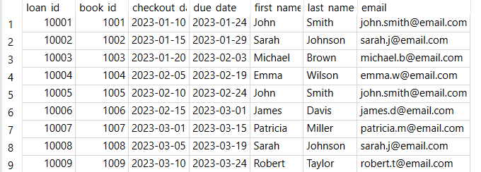

- Multi-table JOIN: Show book details (title, author's full name, genre_name) for each loan, along with the checkout_date and due_date.
select Loans.loan_id, Loans.book_id, Books.title, Authors.first_name, Authors.last_name, Genres.genre_name, Loans.checkout_date, Loans.due_date
from Loans
inner join Books
on Books.book_id = Loans.book_id
inner join Authors
on Authors.author_id = Books.author_id
inner join Genres
on Genres.genre_id = Books.genre_id
;

(30 Results)
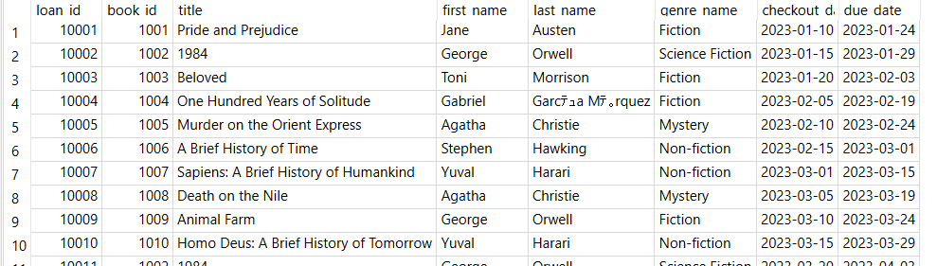

- Self JOIN: Find pairs of patrons who live in the same city. Show both patrons' names and their city.
select first_name, last_name, city, branch_id
from Patrons
order by city asc, branch_id asc, last_name asc;

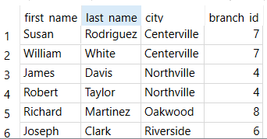
- Multi-table JOIN with filtering: Find all fiction books (genre_id = 1) that have been borrowed, along with the patron name and the branch where they were borrowed from.
select Loans.loan_id, Loans.book_id, Books.title, Patrons.first_name, Patrons.last_name, Patrons.email, Branches.branch_name, Loans.checkout_date, Loans.due_date, Loans.return_date
from Loans
inner join Books
on Books.book_id = Loans.book_id
inner join Branches
on Branches.branch_id = Loans.branch_id
inner join Patrons
on Patrons.patron_id = loans.patron_id
inner join Genres
on Genres.genre_id = 1

(30 results)
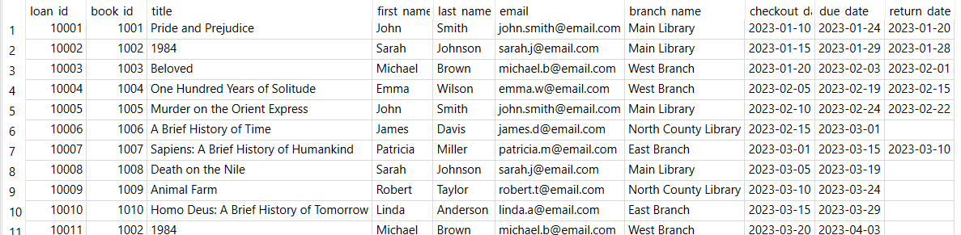

Part 2: Aggregation and GROUP BY Operations
- COUNT aggregation: Count the number of books in each genre category.
select Genres.genre_name, count(book_id) as book_count
from Books
Left Join Genres
On Books.genre_id = Genres.genre_id
group by Books.genre_id
;

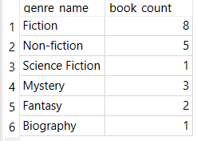

- Multiple aggregations: Calculate the average, minimum, and maximum loan duration (days between checkout and return) for each library branch. Include only returned books.
select branch_id, count(*) as loan_count, min(date(checkout_date)-date(return_date)) as min_days, max(date(checkout_date)-date(return_date)) as max_days, avg(date(checkout_date)-date(return_date)) as avg_days
from Loans
where return_date != ""
group by branch_id
;

- Conditional aggregation: Find patrons with overdue books (due_date < CURRENT_DATE and return_date = ' '), along with the count of overdue books they have.
select count(Loans.book_id) as checked_out, Patrons.first_name, Patrons.last_name, Patrons.email
from Loans
inner join Patrons
on Loans.patron_id = Patrons.patron_id
where Loans.return_date = "" and Loans.return_date < date()
group by Patrons.patron_id;

- Time-based analysis: Analyze monthly borrowing trends. Show the year, month, number of loans, and number of unique patrons for each month.
select count(distinct Patrons.patron_id) as unique_patrons, count(Loans.loan_id) as loan_count, strftime('%Y', Loans.checkout_date) AS year, strftime('%m', Loans.checkout_date) AS month
from Loans
left join Patrons
on Patrons.patron_id = loans.patron_id
order by month ASC
;

BONUS: Write a query to create a simple data dictionary for the library database schema, listing table names, column names, data types, and whether they are primary keys.

CREATE TABLE data_dictionary.Authors (
author_id INT PRIMARY KEY NOT NULL,
first_name VARCHAR(100),
last_name VARCHAR(100),
birth_year DATE,
country VARCHAR(100)
);

CREATE TABLE data_dictionary.Books (
book_id INT PRIMARY KEY NOT NULL,
title VARCHAR(100),
author_id INT FOREIGN KEY NOT NULL,
genre_id INT FOREIGN KEY NOT NULL
isbn TEXT,
publication_year INT
copies_owned INT
);

CREATE TABLE data_dictionary.Branches (
branch_id INT PRIMARY KEY NOT NULL,
branch_name VARCHAR(100),
address VARCHAR(100),
city VARCHAR(100),
phone VARCHAR(100),
);

CREATE TABLE data_dictionary.Genres (
genre_id INT PRIMARY KEY NOT NULL,
genre_name VARCHAR(100),
description VARCHAR(100),
);

CREATE TABLE data_dictionary.Loans (
loan_id INT PRIMARY KEY NOT NULL,
book_id INT FOREIGN KEY NOT NULL,
patron_id INT FOREIGN KEY NOT NULL,
branch_id INT FOREIGN KEY NOT NULL,
checkout_date VARCHAR(100),
due_date VARCHAR(100),
return_date VARCHAR(100),
);

CREATE TABLE data_dictionary.Patrons (
patron_id INT PRIMARY KEY NOT NULL,
first_name VARCHAR(100),
last_name VARCHAR(100),
email VARCHAR(100),
address VARCHAR(100),
city VARCHAR(100),
registration_date DATE,
branch_id INT FOREIGN KEY NOT NULL
);

Discussion Questions
- In our library database, we track which branch a book was borrowed from, but books can exist at multiple branches. How would you modify the schema to track the actual inventory at each branch?
Add an on hand stock quantity for each branch.

- Based on the provided data model, what business questions could library administrators answer using SQL queries that we haven't covered in our exercise?
The library could track the popularity of books.

- How would you extend this schema to track additional patron interactions, such as reserved books, late fees, or participation in library programs?
Count of books on reserve, total of outstanding fees per patron, active in club.

- For tasks 1-3, how could you combine them into a single, more complex query that finds recent history books with multiple copies?
Use a having statement for find all books with “History” then count(book_id) for the results.

- What performance considerations should be kept in mind when running complex joins and aggregations on large library datasets?
Limiting the results when the size of the data set is large will help reduce required processing time for the server.

